10:12 AM 3/26/2024

Supervising

Regresi linear mechine learning

https://www.youtube.com/watch?v=dUPY4CJ-lRM

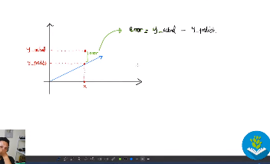

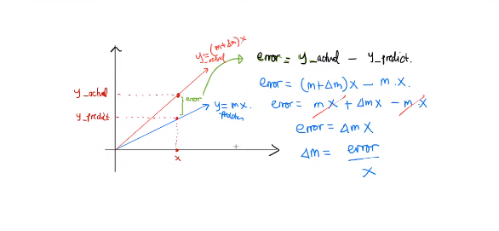Alur regresi linear

Learning rate

